Computer Graphic Assignment 4

Xiang Zhang CS560

The goal of this assignment is to enhance the concept of Texture warping, and understand the basic operation like a triangle-based or quadrilateral-based transformation using either affine, or bilinear, or projective transformation. This assignment is designed to deform an image in a 2D space with interaction by using mouse to click and drag in real time. The warping consists of geometric shape warping and texture warping. This assignment is to enhance the concept of geometric warping, texture (image) operation, and interpolation.

To run the code:

g++  *.c -o  name  -framework OpenGL -framework GLUT

g++  *.cpp -o  name  -framework OpenGL -framework GLUT

1. Texture.c contains the key parts of code for displaying the image “flower.bmp”.

void loadImage(const char *filename)

This is the function of loading image information, which are stored in global variable: BMP _bmp;

void bilinearInterpolation(Point imagePoints[2], Point rectPoints[4]) is the function of bilinear operation, which invoked in the function of void drawScene(void)

When I drag the mouse from the blue dot to red dot, I separate the image into 4 parts and perform the bilinear function for each part.

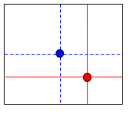

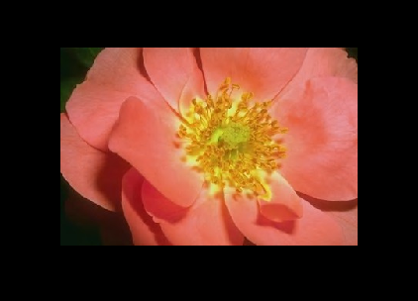 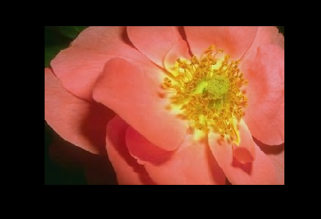

1. void roateAnimation()

This is the automatic rotation function and it is in the menu which will show up by clicking the right mouse.

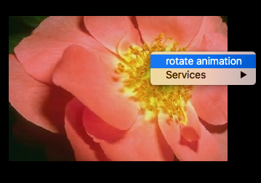

1. Model.cpp contains the parts of code of loading and showing obj file “minicooper.obj”.

void loadObj(string fname) loading the obj data into several vectors: vSets, fSets

void drawObject():

travers the fSets to find the correspond vertex in vSets and then draw the related triangles.

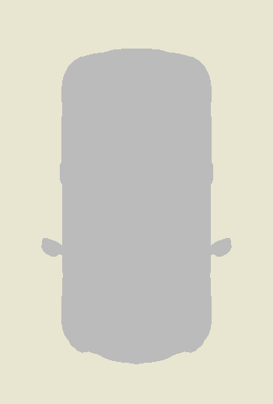

By adding mouseClick and mouseMotion to implement the rotation effect of the model. It implemented by using global variables :

double m_xtheta,double m_ytheta,double m_ztheta;

